Basic Bringup: Cryorefrigerator

# Introduction

This document is an ongoing document detailing the current status of the quick test cryorefrigerator. The intent of this document is to note current problems and attempted solutions as well as providing a history for the project.

# Goals

The goal of this project is to make a cold chamber that can quickly and cost effectively reach ~1K temperatures. The use for this system would be quick tests of samples prior to placing them in the main cryostats that take ages to reach temperature.

# Ongoing Notes

* PT415 spira and o-ring groove. Use recommended sizes based on the plate bottoming out and the spira being on the outside of the oring
  + Meet with Andrew on Monday morning to give him the real specs
* We are going to fold our own radiation shields
* 55k stage will be made out of aluminum
  + Tapped holes going around the stage to attach radiation shield
* Braded heat transfer
  + Thermal conductivity is proportional to electrical conductivity
  + Ask grand river welding if they can weld copper
  + Machine and test copper clamping instead of welding.
    - Copper welding is doable by grand valley welding
      * The even have laser welding capabilities
    - Suggested Silver brazing
* The cooling power as a function of temperature for the 55K stage looks like 16.3sqrt(x-40) eyeballing it from the paper ton PT415 cooling power.

# Stress analysis

Inventor professional has a built in FEM solver for stress. Using this tool it is straightforward to get a rough idea of the deflection which the plate will see under vacuum. A pressure of 15psi was applied to the surface of the plate with the vacuum jacket marked as an immovable object. The result of the calculations is shown in the image below. The takeaway is that for a ¾” austenitic stainless steel plate a maximal deflection of 0.002” is expected.

This is of course just a simulated estimation. Some limitations include gravity not being factored in, using a generic austenitic steel grade for the simulation instead of specifying 316L stainless steel (for example). Also, the weight and the added rigidity of having the flanges populated with equipment was ignored for this test.

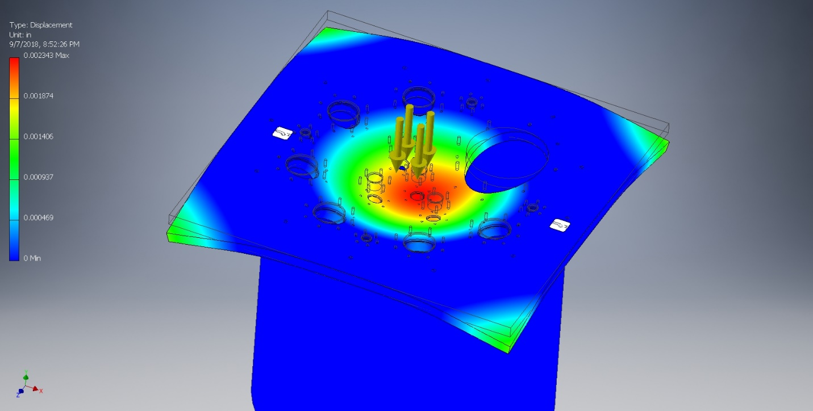

A further test with gravity found no difference. Also initial investigations into the natural harmonics of the steel plate show that modifying the orientation of the holes does not have a significant effect on the dominant vibrational mode. You can see that the spherical harmonics for a disk are predominant (as expected) with additional modes due to the corners vibrating.

# Top Plate Design

## Spira EMI shielding

Spria-shield is a product manufactured by Spira manufacturing. This product looks like a long metal spiral made of a flat continuous strip of metal. The intended use of Spira is providing EMI shielding by sandwiching the Spira between two metal surfaces. The Spira then provides conductive contact between the two metal surfaces screening EMI.

In talking with sales reps from Spira they informed us that for the Spira to effectively screen EMI it must be at 20-25% compression with 25% being the ideal, and that moving away from this ideal compression leads to a rapid drop off in EMI shielding performance.

## Vacuum Jacket Bolt Pattern

The vacuum jacket bolt pattern has been measured properly. Test holes drilled in acrylic with the desired spacing. Test hole was fit on every pair of bolts. The center to center dimension which works is 530.5mm. Using a 24” Vernier the bolt to bolt spacing measured by screwing in a pair of M8 bolts in opposite holes and measuring the greatest distance between the heads of each bolt. The distances measured for two sets of holes was 21.381” and 21.385”. The bolt head a nominally 1/2” diameter head. To within small error the center to center spacing is then 21.381-0.5”. Which makes the measured spacing 530.377mm and 530.479mm. A test hole was made with the dimension 530mm and this did not fit nicely (might have been within the clearance hole tolerance). Using 530.5mm had the test piece fit nicely in every bolt pair.

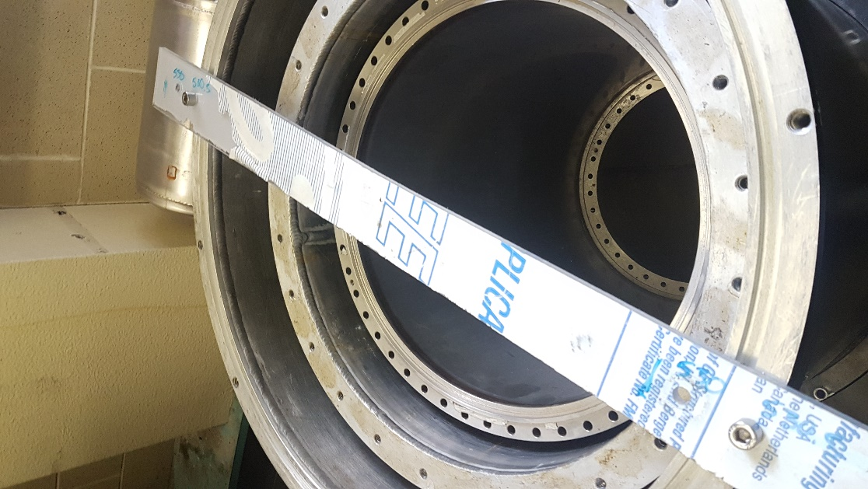

# Radiation Shield

The purpose of this is to reduce the radiated heat leak into the coldest part of the cryostat. (Pg.10 “Experimental techniques in condensed matter”). The first design question addressed was whether to use some pre-existing shields or to manufacture our own. We have decided to repurpose some shields which were laying around, whether this is the best option has not been fulled explored. Of primary concern is the weight of the shields, with secondary concern that they consume too much of the space in the cryostat.

Of the available pre-existing shields here are dimensions and weights:

|  |  |  |  |  |  |  |
| --- | --- | --- | --- | --- | --- | --- |
| Part | ID | OD (in) | Height (in) | Thickness  (Thou) | Weight (lbs) | Material |
| 55K top | 14.5 | 17 | 18.6875 | 186 | 22 | Al |
| 55K bottom | 14.5 | 17 | 25.5 | 186 | 30 | Al |
| 2.8K shield | 11.375 | 12.75 | 32 | ~<140 | 20 | Al |

Also note that the radiation shields available are not the right height for this purpose. As a result they will have to be cut to length, which might be as much work as making custom shields.

For comparison the weights of the radiation shields in the D-wave Cryostat

|  |  |  |
| --- | --- | --- |
| Part | Wall Thickness (thou) | Weight (lbs) |
| 55K Radiation shield (top) |  | 6 |
| 55K Radiation shield (bottom) |  | 15 |
| 2.8K Radiation shield | 66 | 13 |

*note that the thicknesses were estimated using a micrometer and a drill bit so the accuracy of the measurement isn’t excellent.

## Cooling Time Calculation

Using basic unit analysis to calculate how long it will take to cool a 22lb aluminum radiation shield:

This calculation is a good starting point but ignores the fact that heat capacity is a function of temperature which trends towards zero at low temperatures, meanwhile cooling rate is also temperature dependent, increasing with temperature. Thus this is a gross overestimate of the cooling time.

Looking at “Second stage cooling from a Cryomech PT415 cooler at second stage temperatures up to 300 K with cooling on the first-stage from 0 to 250 W” by green if the second stage is sufficiently cold then the first stage cooling power can be estimated as: